UNIX

Operating System🡪 It is an interface and there are different types of operating systems are available

1. Single user with single tasking

2. Single user with multi-tasking

3. Multi user with multi-tasking

Unix🡪 It is operating system and its working as in interface between end user and hardware and it is portable,multi user, multi-tasking, time sharing, it is free ware and open source.

It is from 1960 in market but now some versions are available like🡪Linux,Redhad,Solaris,HP, Ubuntu

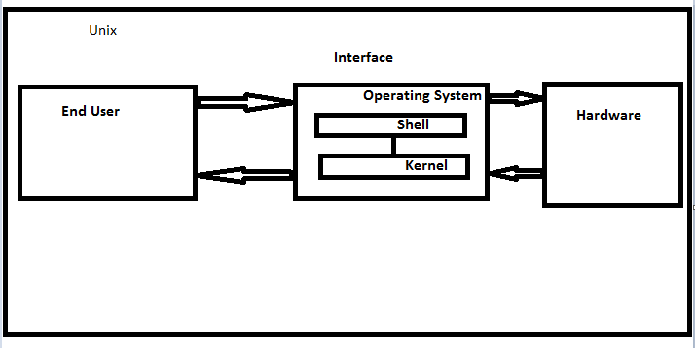

=====================================================================

We are going to practice different commands over virtual terminal🡪

Steps need to follow🡪

1. Open the link <https://cocalc.com/app>
2. Login with gmail/FB
3. Create new project🡪 give name 🡪 click over new project
4. Upload the folder/files( like word,excel, text)

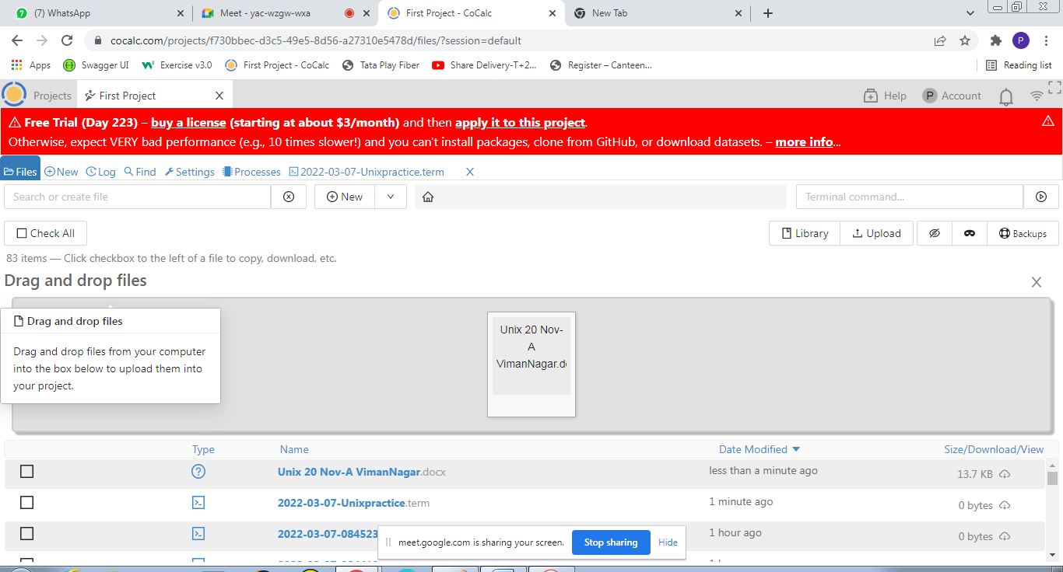

1. New🡪 Terminal🡪 Create terminal with name

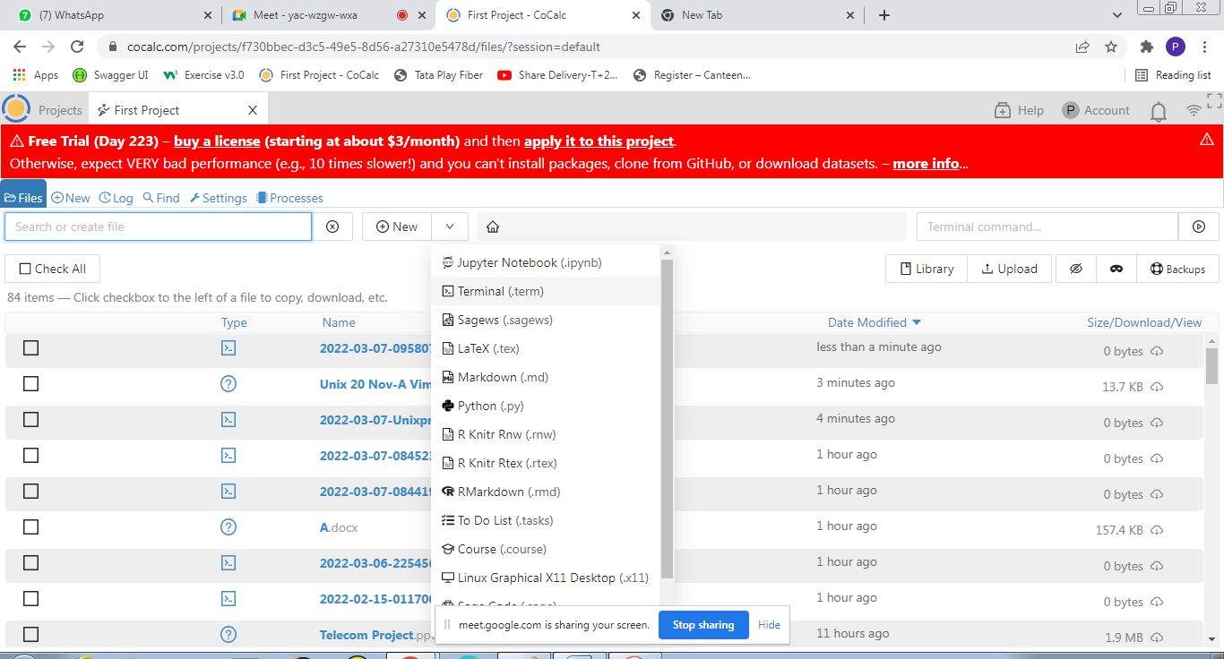

# Commands used in Unix🡪

1.ls🡪 It is used for listing of all files/directories present in present working directory

2.ls –l🡪 Long listing of files/directories ( Details information will available like date, access)

Ex🡪 -rw-r--r-- 1 user user 11300 Mar 6 17:23 TCS.xlsx

drwxr-xr-x 2 user user 2 Feb 15 03:37 W

Initially - 🡪 File

Initially d🡪directory

Initially b🡪 binary file

d | rwx | r-x |r-x

directory|User/owner|group |other

r🡪Read Access

w🡪 Write access

x🡪 Execute access ( Copy/paste/delete/compile)

3. ls –a🡪 it is used for to display hidden files in present working directory

4.ls –r🡪 it is used for reverse order of listing of files

5.ls *.txt🡪 If file name is not known but extension is known

Ex-~$ ls *.txt

Unix.txt 'Viman Nagar May.txt' p.txt

~$ ls *.docx

'04-Revision-03-Vision, mission, PEO, PO, CO draft...... - Copy.docx'

A.docx

'Basic components handling.docx'

'Desicant Stage-1.docx'

'HVAC MCQ-UT-II.docx'

'Investment Banking.docx'

Q.docx

QQQ.docx

'Unix 20 Nov-A VimanNagar.docx'

6.Ctr+l🡪 use for clear the terminal window but history will be available

7.clear🡪 use for clear the terminal window but history wont be available

8.use arrow up & down to access command used in past

9.man 🡪 use for the user manual view

Ex- man ls

10.q🡪 use for to move back to our terminal

11.mkdir directory name🡪 To make new directory/folder

Ex-mkdir pqrs

12.mkdir -p N/{e,f,g,h}🡪 use for the making multiple subdirectories( N is main directory and e,f,g,h are subdirectories)

-p🡪 use for print progress or progress message

13.mkdir -v foldername🡪 use for create new folder with details of folder

-v🡪 verbose used for to get details of folder in command window

14.touch file name🡪 use to create new file

15.touch filename.txt🡪 with extension used for create particular text file

16.rmdir directory name🡪 To remove existing directory but pre condition is directory should be empty

17. rm -r directory name🡪 use for remove directory having data

18. rm –rv directory name🡪 for remove directory with data and verbose for message in command window

Ex-rm -rv B

removed directory 'B/c'

removed directory 'B/h'

removed directory 'B/a'

removed directory 'B'

19. rm file name with extension🡪 To remove existing file

Ex-rm Q.docx

20.rm -I file name with extension🡪 Use to remove file with confirmation

Ex-rm -i EE.docx

rm: remove regular empty file 'EE.docx'? yes

21. rm –I file1 file2 file3 🡪 to remove multiple files with confirmation

Ex-rm -i Unix.txt p.txt

rm: remove regular file 'Unix.txt'? no

rm: remove regular file 'p.txt'? no

21.wc file name with extension🡪 To display word count in particular document

Ex-wc 'Viman Nagar May.txt'

132 |320 |2370 |Viman Nagar May.txt

No of lines|No of words|No of letters| file name

22. head file name with extension 🡪 to display default first 10 lines of particular file

Ex-head 'Viman Nagar May.txt'

23.head –n file name with extension🡪 Use for to displaying no of given lines from documents

Ex-head -5 'Desicant Stage-1.docx'

24. cat file name 🡪 To display data of file or concatenate 2 or more files

cat file1 file2

Ex-cat 'Viman Nagar May.txt' 'Unix.txt'

=====================================================================

25.Chmod🡪 Change the mode ( Access)

Ex-chmod u+r AAA

Initially🡪 d | -wx | r-x |rwx 2 user user 2 Feb 14 19:51 AAA

Directory|u | g | o

Assignment Operators🡪

+ 🡪 to add

* 🡪 to remove

= 🡪 to assign

Ex-chmod u+r AAA

After the chmod operation🡪 d |rwx |r-x|rwx |2 user user 2 Feb 14 19:51 AAA

26.Numeric Way to change Access🡪

Initially 🡪 d | rwx | r-x |rwx 2 user user 2 Feb 14 19:51 AAA

Directory|u | g | o

421🡪 for conversion

rwx | r-x |rwx

111 |101 |111

421🡪 conversion

(u)111🡪4*1 + 2*1 +1*1=7

(g) 101🡪4*1 +2*0 +1*1 =5

(o) 111🡪4*1 + 2*1 +1*1=7

Chmod 757 AAA

Ex- drwxr-xrwx 2 user user 2 Feb 14 19:51 AAA

27.vi🡪 use to edit the existing file or can create a new file and add data or delete data or edit

vi provides a text editor

steps to follow🡪

1.vi file name with extension

2. press I( small i) to go to insert mode

3.Add or edit required data

4.Press “Esc” 🡪 to come out from insert mode

5. shift + ;

6. Wrire wq

7.Press “Enter” to move back to terminal

28.less🡪 will display data page by page

Ex- less 'Viman Nagar May.txt'

* Steps🡪

1.less file name with extension

2.Space bar🡪to move next page

3.b🡪to move previous page

4.g🡪 to move first page from any location

5.shift + g🡪to move last page from any location

6.q🡪 to move back terminal

29.more🡪 will display the data page wise but will display the document percentage

Ex-more file name with extensiom

Space bar🡪 to move next page

q🡪 move back to terminal

30. compress file name with extension🡪 will compress the file and it will replaced with .z file

Ex-compress -v 'Viman Nagar May.txt'

uncompress🡪 Compressed file will uncompressed and .z extension will remove

Ex-uncompress -v 'Viman Nagar May.txt'

Viman Nagar May.txt.Z: 49.7% -- replaced with Viman Nagar May.txt

31.tail file name with extension🡪 will display last 10 lines of documents

Tail –n file name with extension🡪 last given no of lines will display

Ex-tail -5 'Viman Nagar May.txt'

32. grep “pattern name” file name with extension🡪 its work like ctr+f in global level to find out the particular pattern in document

Ex-grep "is" 'Viman Nagar May.txt'

Grep –v “pattern name” file name with extension🡪 it is use display the line which does not have particular pattern

33.kill PID🡪 to stop the process forcefully

To get PID🡪 command is 🡪top

Ex-kill 447

34.mv🡪 use to move the content of one file to another location file

We can not move the directory

Ex-mv 123.docx a.docx

35.cp file name folder name🡪 copy the one file to another folder

Ex- cp a.docx javapractice

36.cd/var/log🡪 If we are facing any issue then we can move in log to see the issue

37. pwd🡪 present working directory

/c/Users/Administrator/Desktop

cd🡪 use to go toward home directory and

cd directory name🡪 Use to move to particular directory

cd .. 🡪 to move back one step

GIT Command🡪

1.git clone http url –b branch name of git🡪 to clone the repositorty in our local system

Ex-git clone https://github.com/kumkaleprashan/Repo1.git -b Repo1

2.git add path of project 🡪 to add the code on git

Ex-Administrator@PRASHANT-PC MINGW32 ~/Desktop

$ git add src/test/java

3.git commit –m “ commit message”

Ex-$ git commit -m "commiting script of mutual fund3.32"

4.git push🡪 to push the code on git repository

Ex- git push

==========================================================================